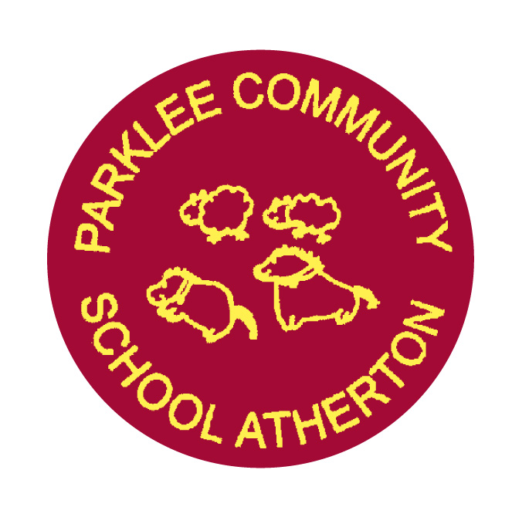
PARKLEE COMMUNITY SCHOOL
Metropolitan Borough of Wigan
Mrs D. Roper BA (Hons) PGCE, NPQH, MA - Headteacher
Miss R .J Wood BSc (Hons), PGCE – Deputy Headteacher

Wardour Street, Atherton, Manchester, M46 0AR
Telephone: 01942 874203 Email – enquiries@admin.parklee.wigan.sch.uk

22/3/2021

Dear Parents/Carers,

At Parklee Community School we follow a Personal, Social and Health Education scheme of work called Jigsaw. As discussed at Parents evening February 2020, during the Summer Term each year group will be completing the sex and relationships aspect of the scheme, ‘Relationships’ and ‘Changing Me’. The ‘Changing Me’ unit is taught over a period of 6 weeks in the second half of the Summer Term. Each year group will be taught appropriate to their age and developmental stage. Please note: at no point will a child be taught something that is inappropriate; and if a question from a child arises and the teacher feels it would be inappropriate to answer, (for example, because of its mature or explicit nature), the child will be encouraged to ask his/her parents or carers at home, and the question will not be answered to the child or class if it is outside the remit of that year group’s programme.

Themes Covered
Foundation Growing up: how we have changed since we were babies
Year 1 Boys’ and girls’ bodies; naming body parts
Year 2 Boys’ and girls’ bodies; body parts and respecting privacy (which parts of the body are private and why this is)
Year 3 How babies grow and how boys’ and girls’ bodies change as they grow older
Year 4 Internal and external reproductive body parts, body changes in girls and menstruation
Year 5 Puberty for boys and girls, and conception
Year 6 Puberty for boys and girls and understanding conception to birth of a baby
All lessons are taught using simple, child-friendly language and pictures, which help children understand changes more effectively.
The key concepts that children learn in Jigsaw are inner strength, self-esteem and resilience. These are really important as they help keep children safe and it helps them make healthy decisions later in life.

From September 2020, Relationships and Health Education are compulsory in all primary schools in England. The new guidance focuses on healthy relationships and keeping children safe in the modern world. It also covers a wide range of topics relating to physical and mental health, wellbeing, safeguarding and healthy relationships. Learning about the emotional, social and physical aspects of growing up, it will give children and young people the information, skills and positive values to have safe, fulfilling relationships and will help them take responsibility for their own well-being. All of the sessions will be age-appropriate and meet the needs of all pupils in the class
Sex education has not been made compulsory in primary schools, however, the Department for Education ‘continues to recommend that all primary schools should have a sex education programme tailored to the age and the physical and emotional maturity of the pupils.’ At Parklee, we feel that Sex Education is important for our pupils, to meet their personal and pastoral needs. It will be taught sensitively and inclusively, with respect to the backgrounds and beliefs of pupils and parents. Parents have the right to request that their child be withdrawn from some or all of the sex education delivered as part of the statutory RSE. To do so, you would need to discuss your concerns with the Mrs Roper, Miss Wood or your child’s class teacher, making it clear which aspects of the programme you do not wish your child to participate in.

Thank you for your continued support

Mrs C Hammond
PSHE Lead

